**Md. Raihan Tapader & Efat Khan**

**ID:204006, 204071**

**Cobweb Model**

**Introduction:** ***Nicholas Kaldor*** introduced the ***"cobweb theorem"*** in 1934, building on earlier analyses by Henry Schultz and Umberto Ricci, originally published in German.

***The cobweb theory describes how price fluctuations can lead to changes in supply, creating a cyclical pattern of rising and falling prices.***

In its simplest form, the cobweb model examines an agricultural market, where supply is influenced by unpredictable factors, such as weather conditions.

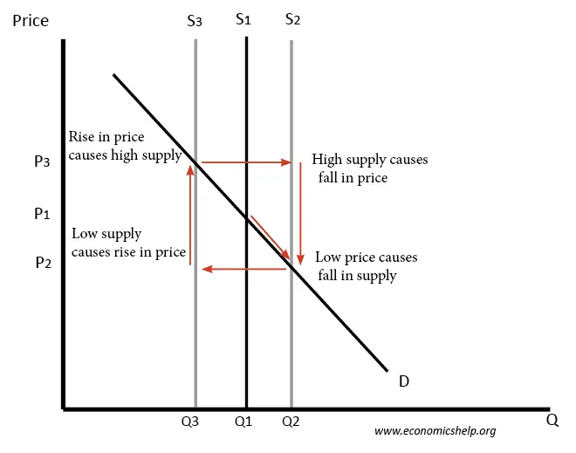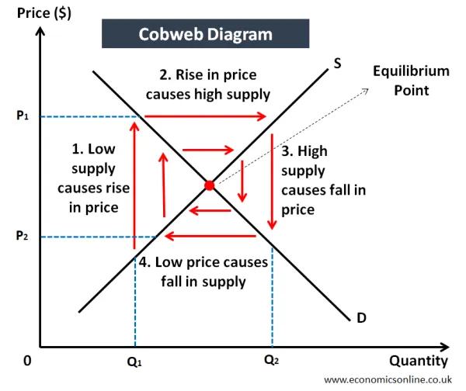

Cobweb Model Graph

The graph illustrates the **Cobweb Model**, showing how price and supply fluctuate in cycles:

1. **Starting Point (Q1, P1)**: At ***equilibrium***, price and supply intersect at **P1** and **Q1**.

### Cycle Explanation:

1. **Starting Point (Q1, P1)**:
   * At equilibrium, price and supply intersect at **P1** and **Q1**.
2. **Low Supply → Price Rises** (S3 → P3):
   * If supply drops to **Q3** due to unexpected conditions (e.g., bad weather), the price increases to **P3**.
3. **High Price → High Supply** (S3 → S2):
   * Encouraged by higher prices, farmers increase supply for the next year to **Q2**, shifting the supply curve right to **S2**.
4. **High Supply → Price Falls** (P2):
   * The increase in supply leads to a surplus, causing prices to drop to **P2**.
5. **Low Price → Supply Falls** (S2 → S3):
   * The low price discourages production, causing supply to reduce again to **Q3**, repeating the cycle.

**Price divergence:** If the slope of **the supply curve is less than the demand curve**, then the price changes could become magnified and the market more unstable.

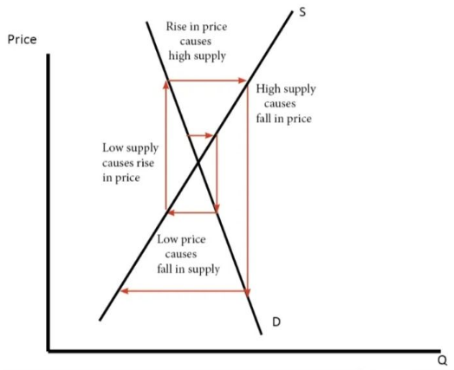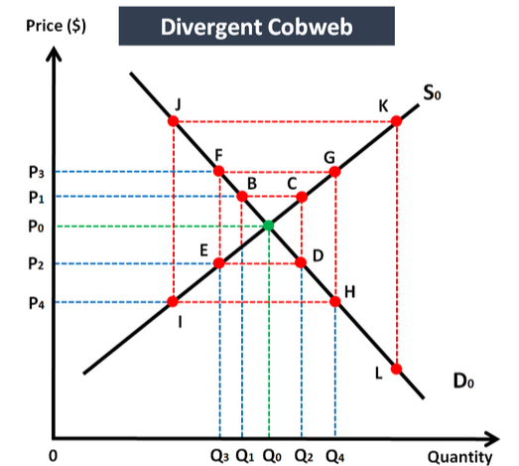

***Note:*** 1. If the **supply curve** tilts **more horizontally** compared to the demand curve, it is flatter (**smaller slope**).

2. If the **demand curve** is **more vertical**, it is steeper.

**Price convergence:** At the **equilibrium point**, if the **demand curve is more elastic** (flatter) than the supply curve, price changes have smaller effects on demand compared to supply.

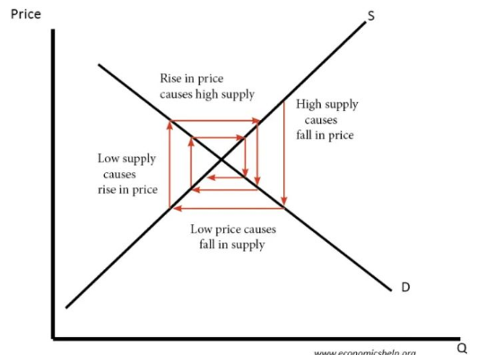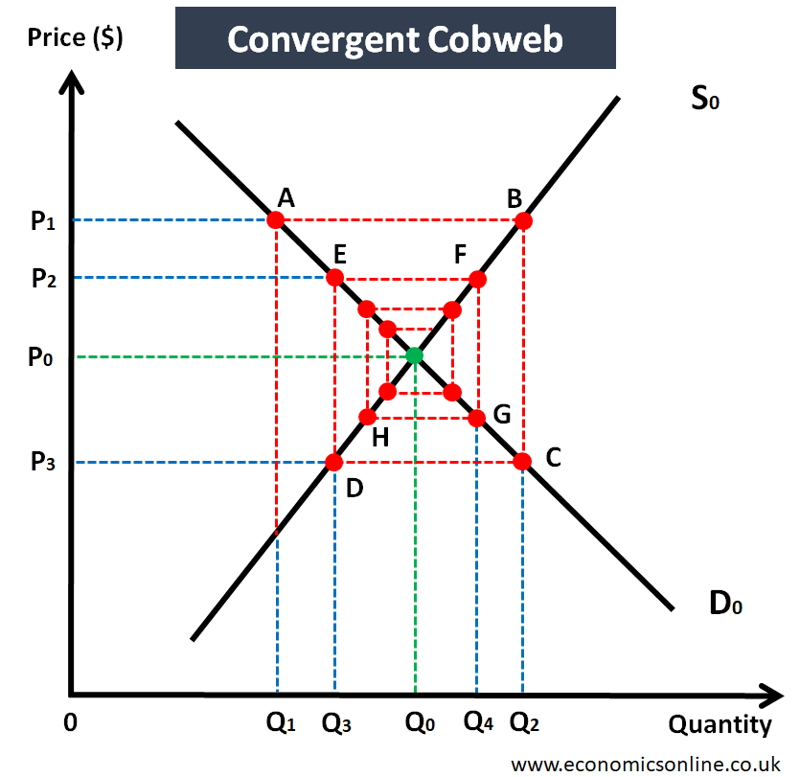

**Title: Solve the cobweb model problem**

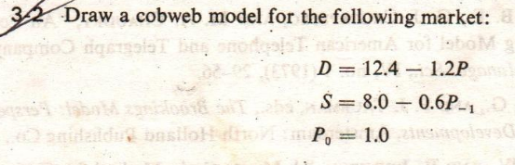

**Solution:**

**At Equlibrium point,**

For Particular solution , let **Pt = Pt-1 = P**

**D = S** so,

12.4-1.2= 8.0-0.6P

12.4-8.0 = 1.2P - 0.6P

P = (12.4-8.0) / (1.2 - 0.6 )

so **P* or P = 7.33**

Putting the value of P in any equation of S or D ,

Now, Q* = 12.4 - 1.2 * 7.33

**Q* = 3.60**

So equilibrium point is ( 7.33 , 3.60 )

**When t=1** means (First Year)

Given **P0** = 1.0

**Q1 = Qs1** = 8.0 - 0.6 P(t-1) = 8.0 - 0.6 P(0) = 8.0 - 0.6 * 1.0 = 7.4

**Qd1 = Q1** = 12.4 - 1.2 Pt

7.4 = 12.4 - 1.2 P1

**P1** = 4.167

……

**Code:**

import matplotlib.pyplot as plt

import numpy as np

# Parameters for demand and supply functions

demand_intercept = 12.4

demand_slope = 1.2

supply_intercept = 8.0

supply_slope = 0.6

# Initial price

P_prev = 1.0  # Initial price (P0)

iterations = 10  # Number of iterations

# Lists to store values for plotting

prices = []

quantities = []

# Iterative calculation for the cobweb path

for i in range(iterations):

    # Calculate quantity supplied based on previous price

    Q_supply = supply_intercept + supply_slope * P_prev

    # Calculate price for the current demand = supply

    P_current = (demand_intercept - Q_supply) / demand_slope

    # Store values for plotting

    prices.append(P_current)

    quantities.append(Q_supply)

    # Update previous price for the next iteration

    P_prev = P_current

# Print the price and quantity at each iteration

print("Iteration\tQuantity (Q)\tPrice (P)")

for i in range(len(prices)):

    print(f"{i+1}\t\t{quantities[i]:.4f}\t\t{prices[i]:.4f}")

# Demand curve function

def demand_curve(Q):

    return (demand_intercept - Q) / demand_slope

# Supply curve function

def supply_curve(Q):

    return (Q - supply_intercept) / supply_slope

# Generate quantities for the demand and supply curves

Q_values = np.linspace(8, 10, 100)

P_demand = demand_curve(Q_values)

P_supply = supply_curve(Q_values)

# Function to plot the cobweb

def plot_cobweb(quantities, prices, demand_curve, supply_curve):

    plt.figure(figsize=(10, 6))

    # Plot demand and supply curves

    Q_values = np.linspace(8, 10, 100)

    plt.plot(Q_values, demand_curve(Q_values), label="Demand Curve", color="blue")

    plt.plot(Q_values, supply_curve(Q_values), label="Supply Curve", color="orange")

    # Plot cobweb path

    for i in range(len(quantities) - 1):

        # Vertical line (from price to supply curve)

        plt.plot([quantities[i], quantities[i]], [prices[i], prices[i + 1]], color="green", linestyle="--")

        # Horizontal line (from supply curve to demand curve)

        plt.plot([quantities[i], quantities[i + 1]], [prices[i + 1], prices[i + 1]], color="green", linestyle="--")

    # Add equilibrium lines

    plt.axhline(y=(12.4 - 8.0) / (1.2 + 0.6), color="red", linestyle="--", label="Equilibrium Price")

    plt.axvline(x=9.47, color="green", linestyle="--", label="Equilibrium Quantity")

    # Labeling axes and adding title

    plt.xlabel("Quantity (Q)")

    plt.ylabel("Price (P)")

    plt.title("Cobweb Model with Convergence/Divergence")

    plt.legend()

    plt.grid()

    plt.show()

# Plot the demand and supply curves with the cobweb path

plot_cobweb(quantities, prices, demand_curve, supply_curve)

**Graph:**

